Title; No Blank Line Between the Title and the Paper Top Margin; Page-Centered; Max. 3 Lines

Surname N.1, Surname N.2, Surname N.2,* and Surname N.1

1Affiliation and address

2Affiliation and address

*corresponding author:

e-mail: xxxxxxxxxxxxxxxx

**PREPARATION AND SUBMITTAL**

The Book of Extended Abstracts, which will be given to participants at registration, will be reproduced directly from your manuscript. Abstracts must be produced to fit A4 paper. The text, together with tables, equations and illustrations, must fill **no more than two pages**, in 2-column layout (as in this accompanying example).

**SUBHEADING**

Authors are required to supply Extended Abstracts in docx MS Word format. Submissions can be received via the online abstract submission system.

**SUBHEADING**

The official language for the Abstract of the conference: English. Paper Format: A4 portrait. Margins: All the margins should be 2 cm from Top and Bottom, 1.5 cm from Left and Right. Columns: main text in two columns, justified; equal column width. Spacing: before and after: 0 pt: line spacing: single. Font: for the title: size 12 Times New Roman, bold; for the names of the authors: size 10 Times New Roman, bold; for the text: size 10 Times New Roman, regular. Page numbering: no page numbers. Title: leave no blank line between the title and the paper top margin; the title must be page-centered and maximum of three (3) lines.

Name(s) of authors(s): the name of the authors and their affiliations must be presented as succinctly as possible, including the e-mail address of each author. Main text: in 2 columns, two page maximum, including figures and tables; paragraphs separated by one line. Footnotes: do not use footnotes. Figures and tables: include thefigures and tables precisely in the place you want them.

**SUBHEADING**

Mathematics: equations should be typed into the body of the text, or incorporated as an equation editor or graphic object; equations should be numbered. Bibliographic references: in the text, indicate only the last name of the author/s followed by the year of publication in parentheses, e.g. Dimas (2020); if there are several references of the same author in the same year, use a suffix a, b,.. after the year; make a list of references at the end of the text sorted by alphabetic order of the last name of the first author, followed by the names of the co-authors (if any), editor, place and year of publication (or complete reference of the journal where the article or paper was published). File format for submission: use docx format (max file size 10 MB); identify the files as “Abstract_<first author last name>.docx”. Send it by no later than January 31, 2025 via the online submission system.

If you have any queries on the preparation of your abstract, please contact the Secretariat of DMPCO 2025; e-mail: [info@dmpco.eu](mailto:info@dmpco.eu).

**Table 1.** Title of the table

|  |  |
| --- | --- |
| **Text** | **Text** |
| Text | Text |
| Text | Text |

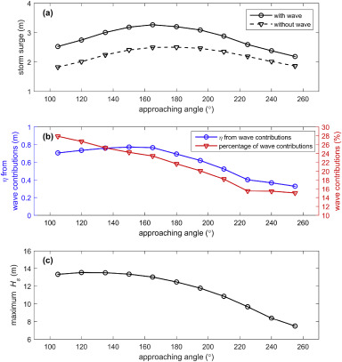

**Figure 1**. Sensitivity of storm surge,

**ATTENTION**

Please note that this example of the Extended Abstract is a style sheet, which makes the work much easier. Please do not try to include more text on each A4 page than the space provided by this instruction. If your abstract does not comply with this instruction, it will be rejected.

**ACKNOWLEDGEMENTS**

Acknowledgements may appear before the list of references.

**REFERENCES**

See the following examples:

Fredsøe, J., & Deigaard, R. (1992). Mechanics of coastal sediment transport. Singapore: World Scientific.

O'Donoghue, T., Doucette, J.S., Van der Werf, J.J., & Ribberink, J.S. (2006). The dimensions of sand ripples in full-scale oscillatory flows. *Coastal Eng.* 53, 997–1012.